**Markup language:**

* HTML
* CSS

**TEXT EDITOR:**

* NOTEPAD
* NOTEPAD++

**BROWSER:**

* CROME
* OPERA
* INTERNET
* EXPLORER
* FIREFOX

**FILE DETAIL:**

**TABS:**

* HOME PAGE
* HOME
* FEATURES
* CLASSES
* LOGIN

|  |
| --- |
|  |
| E:\project\repoose\5605.jpg |
|  |
|  |
|  |
|  |
|  |
|  |
|  |
|  |
|  |
| E:\project\repoose\kohinoor-business-school-management-college.jpg |
|  |
|  |
|  |

**CODING**

**NAME OF WEBSITE HOMEPAGE “ROPOSEE” :**

**CODING IN HTML:**

<!DOCTYPE HTML>

<HTML>

<HEAD>

<LINK REL="STYLESHEET"TYPE="TEXT/CSS"

HREF="p.css">

</HEAD>

<BODY>

<DIV CLASS="HEADER">

<H2>ROPOOSEE</H2>

</DIV>

<DIV CLASS="TOPNAV">

<A HREF="E:\project\home.html">HOME</A>

<A HREF="E:\project\features.html">FEATURES</A>

<A HREF="E:\project\classes.html">CLASSES</A>

<A HREF="E:\project\login.html"STYLE="FLOAT:RIGHT">LOGIN</A>

</DIV>

<DIV CLASS="ROW">

<DIV CLASS="LEFTCOLUMN">

<DIV CLASS="CARD">

<H2>WELCOME</H2>

<H4>WORK HARD</H4>

<DIV CLASS="UNIVERSITY"><IMG SRC="E:\project\PHOTOS\ROPOSEE.jpg"

ALT="IMAGES OF ROPOOSEE"WIDTH100%></DIV>

<P>ROPOSEE'S DESK</P>

<P ALIGN="JUSTIFY">The University is one of the oldest and premier Universities of India. I am honoured and greatly privileged to lead this great Institution; and continue to address the imminent challenges and to harness theovert and covert opportunities, in order to satisfy our stake holders. A unique of its kind, currently the University has 56 Departments, 12 specialized Centres, 781 Affiliated Colleges, 2 main Campuses, 2 sub Campuses, 2 Model Colleges, and the ‘School of Engineering and Applied Sciences’ at Kalyan as the University’s own Engineering College. It has perhaps the largest geographical area under its jurisdiction from Thane district to Sindhudurg district, a spread of more than 600 km.

Teaching-Learning, Research, Consultancy, and Innovation are our strong arms to achieve the objectives, and we strive to nourish them to keep them contemporary and effective. The University is committed to create and maintain world class facilities, and create knowledge in the frontier areas of human understanding; keeping in mind the societal needs. We provide diverse opportunities and appropriate guidance to the young students coming into our fold and transform them into self-reliant, responsible, and mature citizens.

With strongly belief in the saying, “Educationists should build the capacities of the spirit of inquiry, creativity, entrepreneurial and moral leadership among students and become role model”(Late former President of India, Dr. A.P.J. Abdul Kalam). I am confident that the University of Mumbai is marching in the right direction, shaping the human resources, and contributing to the nation building.

</P>

</DIV>

<DIV CLASS="CARD">

<H2>SERVICES OFFERED BY OUR UNIVERSITY</H2>

<H4>QUALITY TRAINING,SPECIALISED CLASSES,MODERN TECHNIQUES</H4>

</DIV>

<DIV CLASS="GALLERY">

<IMG SRC="E:\project\PHOTOS\5605.jpg"HEIGHT="250">

<IMG SRC="E:\project\PHOTOS\tt.jpg"HEIGHT="250">

<IMG SRC="E:\project\PHOTOS\UniLebenSlider2.jpg"HEIGHT="250">

<IMG SRC="E:\project\PHOTOS\university-img.jpg"HEIGHT="250">

</DIV>

</DIV>

<DIV CLASS="RIGHTCOLUMN">

<DIV CLASS="CARD">

<H4>MAIL ID:ZING080814@GMAIL.COM</H4>

<H4>PHONE NUMBER:5528463</H4>

</DIV>

<DIV CLASS="CARD">

<H3>MOST POPULAR</H3>

<H4>ELLIPTICAL TRAINERS</H4>

<H4>EXERCISE EQUIPMENT FOR WORKS</H4>

</DIV>

<DIV CLASS="CARD">

<H3>FOLLOW ME</H3>

<TITLE>MAILTO LINK</TITLE>

<!--link to Home page of gmail-->

<A HREF="http://www.gmail.com/"><img src="GMAIL.png"height="50"width="50"></A>

<A HREF="http://www.twitter.com/"><img src="twitter.png"height="50"width="50"></A>

<A HREF="http://www.instagram.com/"><img src="Instagram_icon.png"height="50"width="50"></A>

<A HREF="http://www.youtube.com/"><img src="youtube.png"height="50"width="50"></A>

</div>

</div>

</div>

<div class="footer">

<h5>copyright@2019poornima inc. All rights reserved Site map</h5>

</div>

</body>

</html>

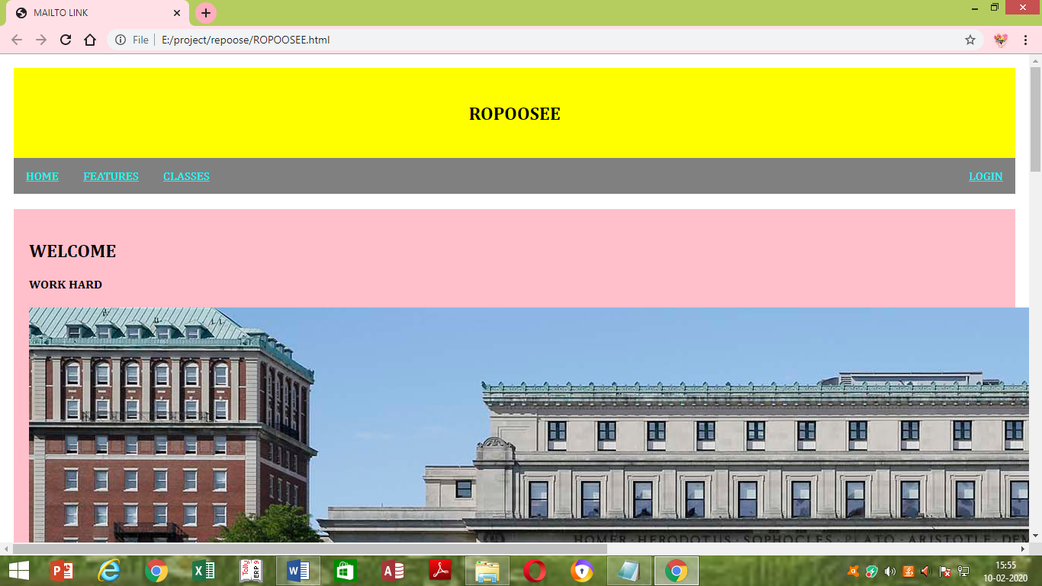

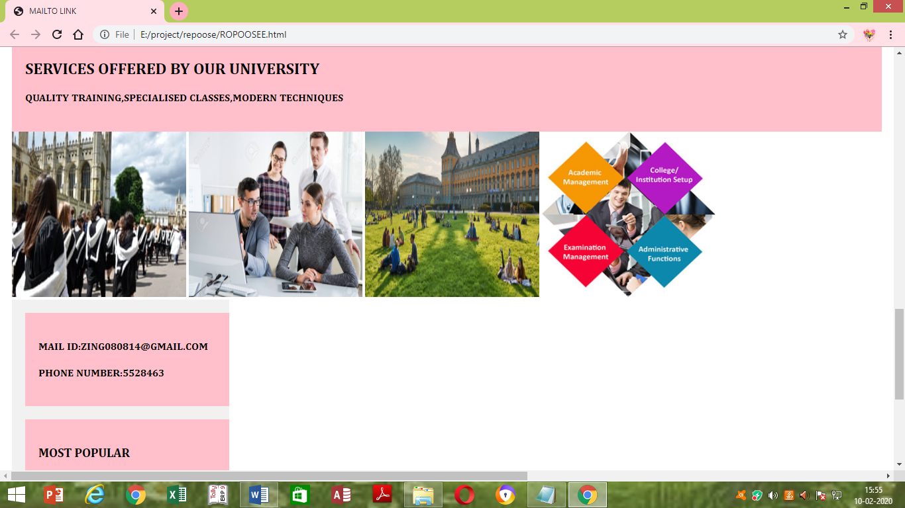

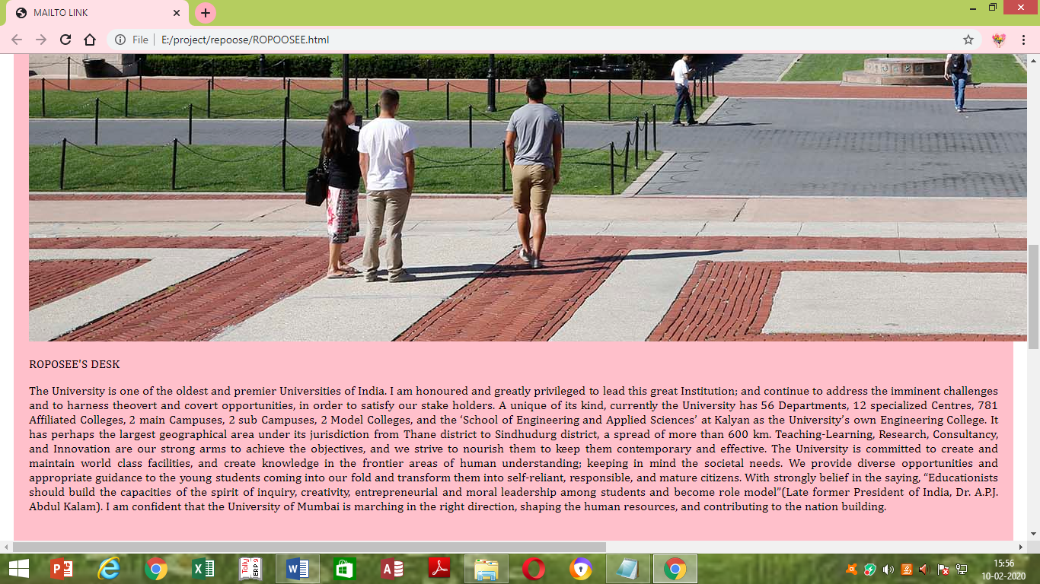

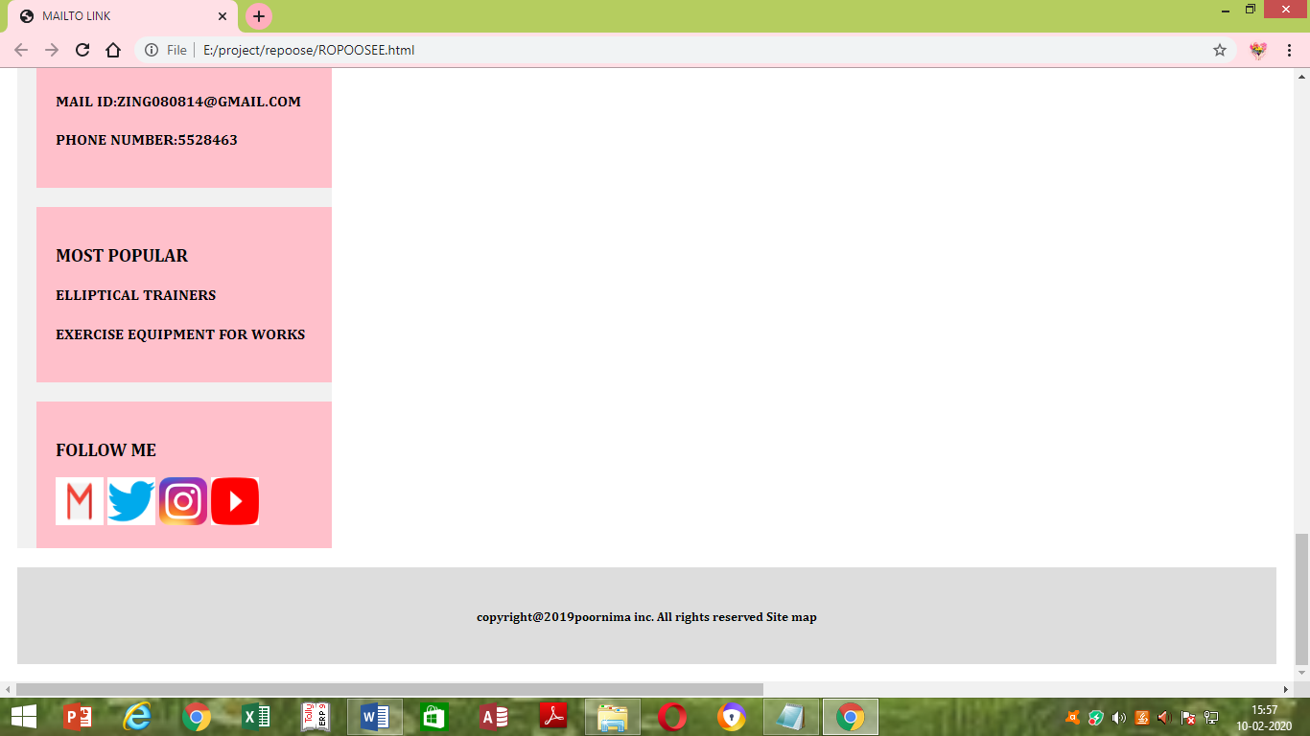

CODING IN CSS:

*{

BOX-SIZING:BORDER-BOX;

}

BODY{

FONT-FAMILY:CAMBRIA;

PADDING:10PX;

BACKGROUND:CREAM;

}

/*HEADER/BLOG TITLE*/

.HEADER{

PADDING:25PX;

TEXT-ALIGN:CENTER;

BACKGROUND:YELLOW;

}

.HEADER H1{

FONT-SIZE:90PX;

}

/*STYLE THE TOP NAVIGATION BAR*/

.TOPNAV{

OVERFLOW:HIDDEN;

BACKGROUND-COLOR:GREY;

}

/*STYLE THE TOPNAV LINKS*/

.TOPNAV A{

FLOAT:LEFT;

DISPLAY:BLOCK;

COLOR:AQUA;

TEXT-ALIGN:CENTER;

PADDING:14PX 16PX;

TEXT-DECORATION:Cambria Math;

}

/*change color on hover*/

.topnav a:hover{

background-color:#ddd;

color:black;

}

/*create two unequal columns that floats next to each other*/

/*left column*/

.leftcolumn{

float:left;

width:75%;

}

/* RIGHT COLUMN*/

.RIGHTCOLUMN{

FLOAT:LEFT;

WIDTH:25%;

BACKGROUND-COLOR:#F1F1F1;

PADDING-LEFT:20PX;

}

DIV:GALLERY{

BORDER:1PX SOLID #CCC;

}

DIV:GALLERY:HOVER{

BORDER:1PX SOLID #777;

}

DIV.GALLERY IMG{

WIDTH:20%;

}

/*IMAGE*/

.IMG1{

BACKGROUND-COLOR:#AAA;

WIDTH:20%;

PADDING:10PX;

}

/*ADD A CARD EFFECT FOR ARTICLES*/

.CARD{

BACKGROUND-COLOR:PINK;

PADDING:20PX;

MARGIN-TOP:20PX;

}

/*CLEAR FLOATS AFTER THE COLUMNS*/

.ROW:AFTER{

CONTENT:"";

DISPLAY:TABLE;

CLEAR:BOTH;

}

/*footer*/

.footer{

padding:20px;

display:block;

text-align:center;

background:#ddd;

margin-top:20px;

}

/*responsive layout-when the screen is less than 800px wide,

make the two columns stack on top of each other intead of next

to each other*/

@media screen and (max-width:800px){

.leftcolumn,.rightcolumn{

width:100%;

padding:0;

}

}

/*responsive layout-when the screen is less then 400px wide,

make the navigation links stacks on top of each other intead

of next to each other*/

@media screen and (max-width:400px){

.topnav a {

float:none;

width:100%;

}

}

**CODING FOR HOME TAB :**

<html>

<head>

<title>marksheet iti</title>

</head>

<body>

<!--opens the link in new window-->

<a href="project/2nd.html"></a>

<hr>

<h1 style="font-size:300%;TEXT-align:center;color:BROWN;FACE="Calibri">HOME</h1>

<hr>

<DIV CLASS="ROW">

<DIV CLASS="LEFTCOLUMN">

<DIV CLASS="CARD">

<DIV CLASS="UNIVERSITY"><IMG SRC="E:\project\PHOTOS\ROPOSEE.jpg"

ALT="IMAGES OF ROPOOSEE"WIDTH=100%ALIGN="CENTER"></DIV>

<B><P><font color="blue"size="6"face="callibri">OUR COURSES</font></P></B>

<P ALIGN="JUSTIFY"><font color="dark green"size="5"face="callibri">our university has top grades,it has various fiels u like.it gives gurantee to scholars to get a good job package</font>

</P>

</DIV>

</DIV>

</DIV>

<hr>

<DIV CLASS="CARD"><br><br>

<H2><font color="chocolate"size="10"face="callibri">SERVICES OFFERED BY OUR UNIVERSITY</font></H2>

<br><br>

<H4><font color="dark blue"size="5"face="callibri">QUALITY TRAINING,SPECIALISED CLASSES,MODERN TECHNIQUES</H4>

</DIV>

<DIV CLASS="GALLERY">

<IMG SRC="E:\project\PHOTOS\5605.jpg"HEIGHT="250">

<IMG SRC="E:\project\PHOTOS\tt.jpg"HEIGHT="250">

<IMG SRC="E:\project\PHOTOS\UniLebenSlider2.jpg"HEIGHT="250">

<IMG SRC="E:\project\PHOTOS\university-img.jpg"HEIGHT="250">

<hr>

<marquee>latest syllabuss revised as per new session of the year 2020</marquee>

<hr>

</DIV>

</body>

</html>

**OUTPUT:**

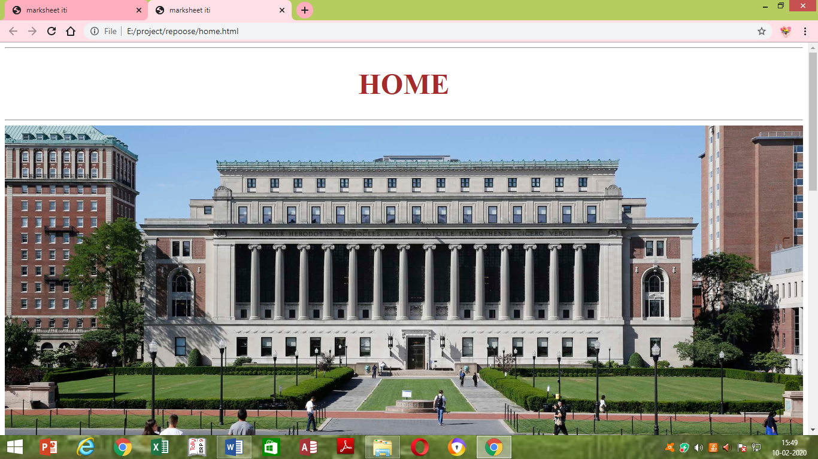



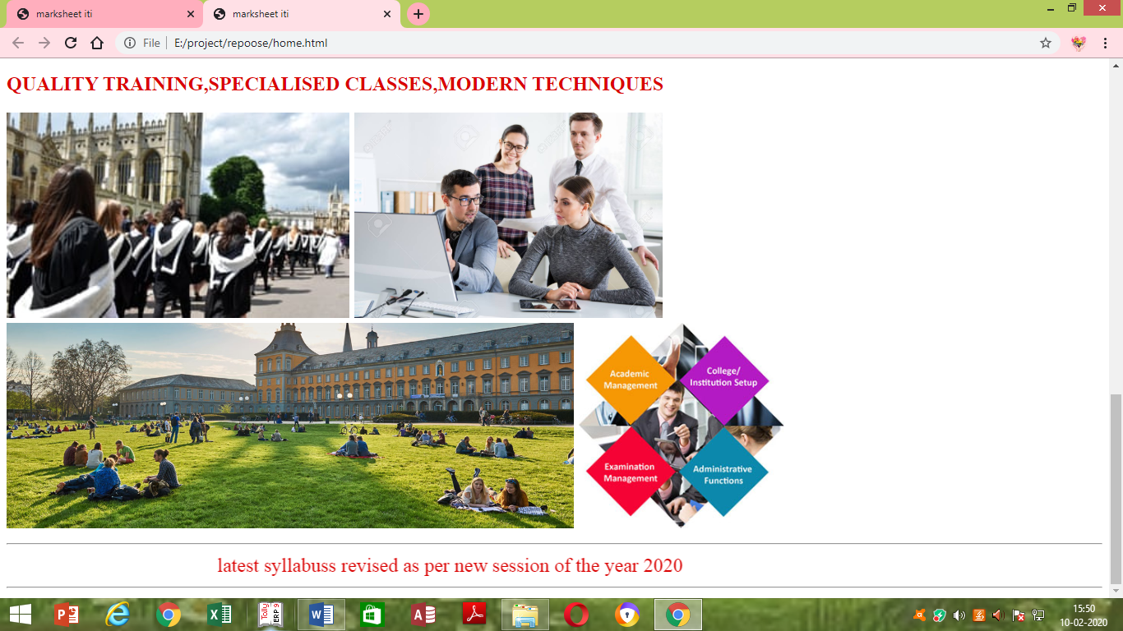

**CODING FOR FEATURES:**

<html>

<head>

<title>marksheet iti</title>

</head>

<body>

<!--opens the link in new window-->

<a href="project/2nd.html"></a>

<h1 style="font-size:300%;text-align:center;color:light yellow;">FEATURES</h1>

<H2><dt>Features of the University</dt></H2>

<h3><dd>A university that seeks to improve the qualifications and abilities of teachers

At every stage of its undergraduate, master's, professional degree, and doctoral programs, the university seeks to have teachers learn and study topics in line with the goals and level of those programs and refine their ability to teach. The university also seeks to use results of research combining educational theory and practice ("Educational Practices") to enhance teacher education.</dd></h3>

<h2><dt>A university that is open to society</dt></h2>

<h3><dd>The university seeks to be "a university that is open to society." The Graduate School, for example, accepts current teachers from kindergarten to high school. The university also makes its facilities available for projects like cooperation with the "Comprehensive Psychological Training Center" established by Hyogo Prefecture. The university provides clinical psychological counseling at the Center for Research on Human Development and Clinical Psychology, the university allows public access to its libraries and sports facilities, and the university hosts lecture courses for the general public. The university also used its intellectual and physical resources to establish the Center for Regional Exchange in order to coordinate and cooperate with the local community.

In addition, the university established its "Kobe Satellite" in Kobe to hold nighttime classes so that current teachers have more opportunities to study at the Graduate School while working.</dd></h3>

<h2><dt>A faculty of teachers in a range of specialties</dt></h2>

<h3><dd>The university has instructors in a range of academic specialties like pedagogy, psychology, and course curriculum studies so that students can learn and study a variety of disciplines.

The university seeks to seamlessly and cohesively organize these disciplines in accordance with the role of education and facilitate learning and study.</dd></h3>

<h2><dt>Enjoyable campus life<dt></h2>

<h3><dd>The university provides an enjoyable environment for students. The university's vast 40-hectare campus has student housing (560 single-room residences, 120 units for family housing), an international house (28 single rooms, 8 units for couples, and 4 units for families), sport facilities that include an athletic field, a baseball field, and tennis courts, and parking for about 1200 cars (including 430 parking spaces for students in student housing).<dd></h3>

</dl>

<dl>

<H2><dt>Faculty of School Education</dt></H2>

<h3><dd>The Faculty of School Education fosters elementary school teachers with exceptional leadership ability in a range of subjects and areas accompanied by vast interpersonal skills and extensive expertise.

A curriculum that emphasizes practical ability,The overall curriculum is organized and coordinated over 4 years so that students gain the overall ability to serve as elementary school teachers in addition to basic knowledge in a range of disciplines.Students are given a practical education (in educational practices) throughout their 4 years of study. The curriculum is organized into a concurrent form so that of results learning through liberal arts courses, teaching profession courses, educational practices and reflection courses, and specialized subjects courses are integrated and incorporated through each year of practical education.</dd></h3>

<H2><dt>The Cultivation of "Teacher as Active Learner" through the Standard for Initial Teacher</dt></H2>

<h3><dd>The university have developed the Standard for Initial Teacher which outlines what is expected of a teacher in order to make sure all teachers have the aptitude to teach, and to establish university-wide leadership system. Through self-evaluation using the Standard for Initial Teacher, one can continually look back on one's own education, discover problems and plan for future studies. Doing this over a lifetime is how one becomes a"teacher as Active Learner."</dd></h3>

<h2><dt>Employment Support that assures a High Teacher Employment Rate and Wide-scale Career Development Support</dt></h2>

<h3><dd>Centering around the Career Development Center, we strive for complete career development and employment support by creating systematic and continuous programs. We provide detailed employment support that meets the needs of students by making sure that university faculty, career counselors, and career development advisors with professional experience such as principals can be consulted. We also do diverse career development support matching that students can participate in soon after admission.</dd></h3>

</dl>

</body>

</html>

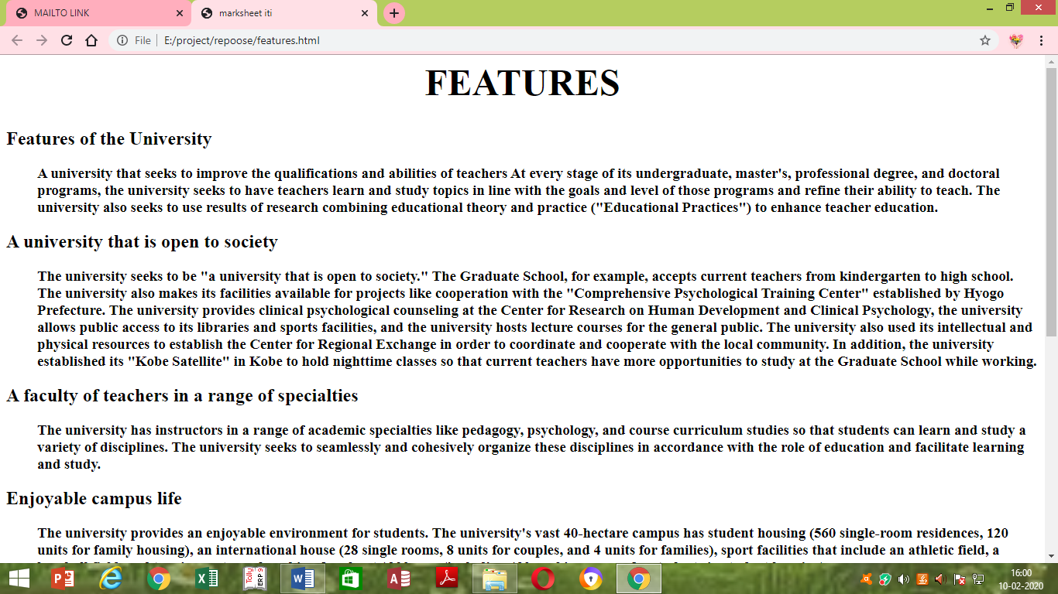 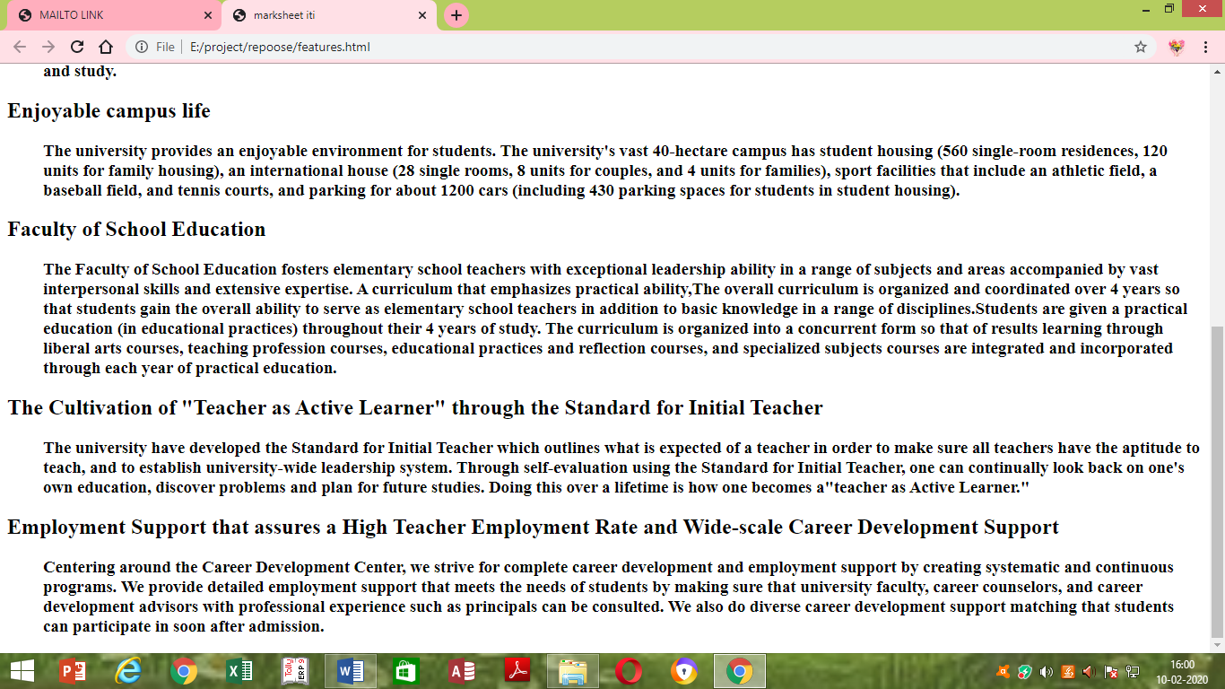

**CODING FOR CLASSES:**

<html>

<head>

<title>marksheet iti</title>

</head>

<body>

<!--opens the link in new window-->

<a href="project/2nd.html"></a>

<h1 style="font-size:300%;text-align:center;color:aqua;">classes</h1>

<img src="E:\project\PHOTOS\kohinoor-business-school-management-college.jpg"HEIGHT="250">

<img src="E:\project\PHOTOS\download.jpg"HEIGHT="250">

<img src="E:\project\PHOTOS\Hatekar_classesBigpic.jpg"HEIGHT="250">

<img src="E:\project\PHOTOS\new_banner1.jpg"HEIGHT="250">

<img src="E:\project\PHOTOS\download.jpg"HEIGHT="250">

<img src="E:\project\PHOTOS\nmims-classroom-2.jpg"HEIGHT="280">

</body>

</html>

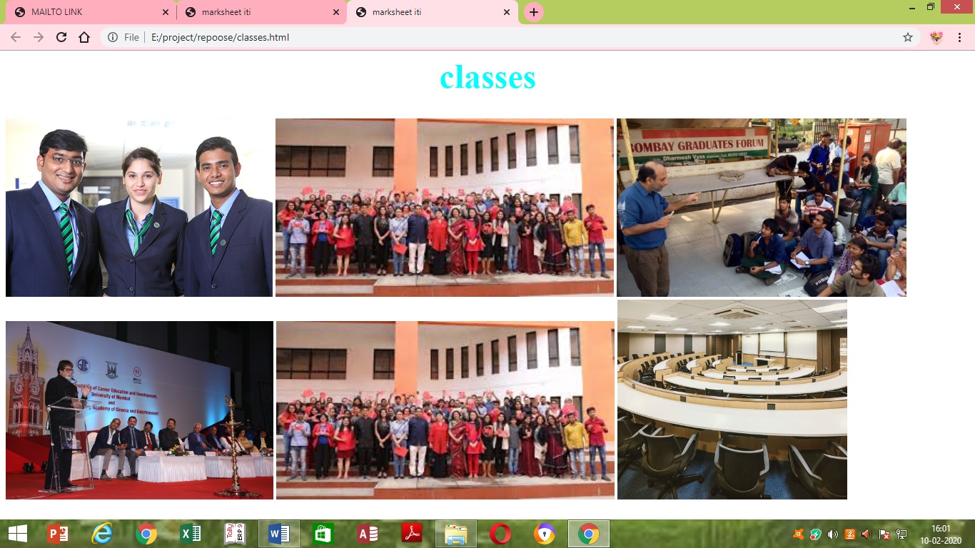

**CODING FOR LOGIN:**

<!DOCTYPE HTML>

<HTML>

<BODY >

<FORM ACTION="/*ACTION _PAGE.PHP"METHOD="GET">

<H1>STUDENT INFORMATION SYSTEM</H1>

<BR><BR>

<B>NAME:</B>&emsp; &emsp; &emsp;

<INPUT TYPE"TEXT"NAME="NAME"><BR><BR>

<B>FATHER'S NAME:</B><INPUT TYPE="TEXT"

NAME="FNAME"><BR><BR>

<B>MOTHER'S NAME:</B><INPUT TYPE="TEXT"

NAME="MNAME"><BR><BR>

<B>DATE OF BIRTH:</B>

<INPUT TYPE="DATE"NAME="BDAY"><BR><BR>

<B>GENDER:</B><BR>

&emsp; &emsp;<INPUT TYPE="RADIO"

NAME="GENDER"VALUE="MALE">MALE<BR>

&emsp; &emsp;<INPUT TYPE="RADIO"

NAME="GENDER"VALUE="FEMALE" CHECKED>

FEMALE<BR>

&emsp; &emsp;<INPUT TYPE="RADIO"

NAME="GENDER"VALUE="OTHER">OTHER<BR><BR>

<B>COMMUNICATION ADDRESS:<BR>

<TEXTAREA ROWS="6"COLS="50">

</TEXTAREA><BR><BR>

<B>TRADE:</B>&EMP;

<SELECT NAME="TRADE">

<OPTION VALUE="T1">COPA</OPTION>

<OPTION VALUE="T2"SELECTED>INFORMATION TECHNOLOGY,/OPTION>

<OPTION VALUE="T3">INFORMATION COMMUNICATION TECHNOLOGY&SYSTEM MAINTENANCE</OPTION>

<OPTION VALUE="T4">COMPUTER HARDWARE&NETWORK MAINTENANCE</OPTION>

</SELECT>

<BR><BR><BR><BR><BR><BR>

<B>LANGUAGES YOU KNOW:</B><BR><BR>&emsp; &emsp; &emsp;

<SELECT NAME="LANGUAGE"MULTIPLE>

<OPTION VALUE="TAMIL" SELECTED>TAMIL

<OPTION VALUE="HINDI">HINDI

<OPTION VALUE="ENGLISH" SELECTED>ENGLISH

<OPTION VALUE="MALYALAM">MALYALAM

<OPTION VALUE="KANNADA">KANDDA

</SELECT>

<BR><BR>

<B>COMPUTER KNOWLEDGE:</B><BR><BR>

&emsp; &emsp; &emsp;&emsp;

<INPUT TYPE="CHECKBOX"NAME="SOFTWARE1"

VALUE="WINDOWS">WINDOWS OS

<BR>

&emsp; &emsp; &emsp;&emsp;

<INPUT TYPE="CHECKBOX"NAME="SOFTWARE2"

VALUE="MSOFFICE">MICROSOFT OFFICE

<BR>

&emsp; &emsp; &emsp;&emsp;

<INPUT TYPE="CHECKBOX"NAME="SOFTWARE3"

VALUE="HTML">HYPER TEXT MARKUP LANGUAGE

<BR>

&emsp; &emsp; &emsp;&emsp;

<INPUT TYPE="CHECKBOX"NAME="SOFTWARE4"

VALUE="CSS">CASCADED STYLE SHEET

<BR>

<BR>

<INPUT TYPE="SUBMIT"VALUE="SUBMIT">

<INPUT TYPE="RESET">

</FORM>

</BODY>

</HTML>

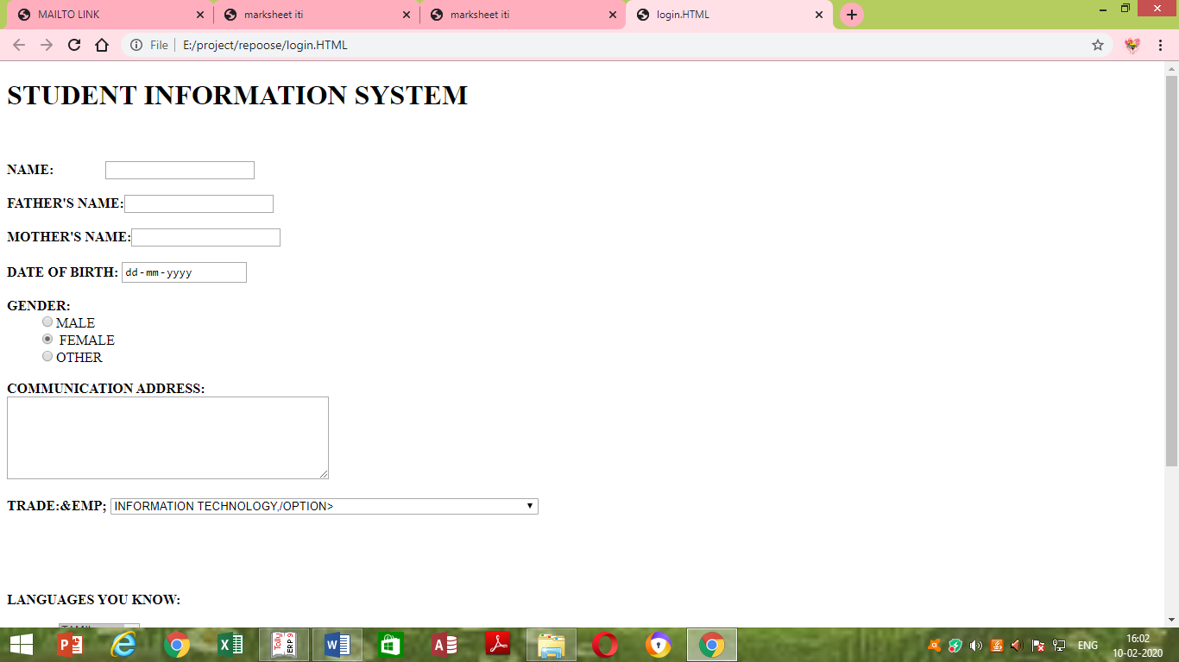 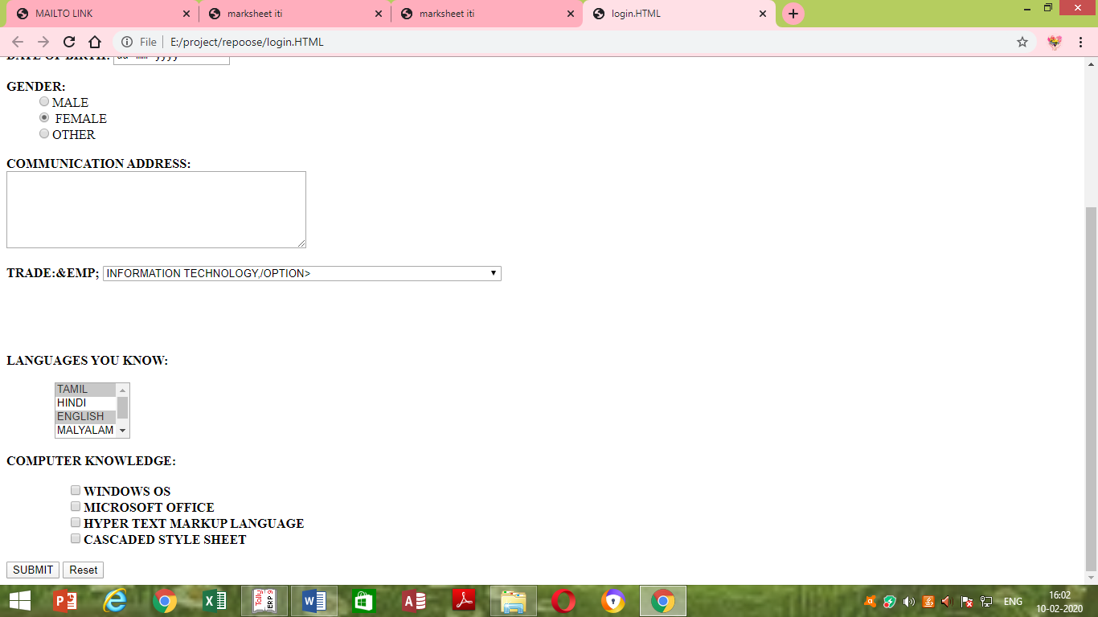

**THANKING YOU**